

**Sustaining the recovery**

Speech given by

Charlie Bean, Deputy Governor for Monetary Policy, Bank of England

North East Chamber of Commerce President’s Club Talk, Rockcliffe Hall Hotel, Darlington 10 March 2014

All speeches are available online at [www.bankofengland.co.uk/publications/Pages/speeches/default.aspx](http://www.bankofengland.co.uk/publications/Pages/speeches/default.aspx)

Good afternoon! The past six years have been a difficult time for businesses across the country. But at last there are unmistakable signs that a robust recovery is under way. According to the present vintage of official data, output has risen in each of the past four quarters, taking the four-quarter growth rate to a healthy 2.7%, the highest since early 2008. The message from business surveys, such as those produced by the Chambers of Commerce, is that growth has, if anything, been even stronger. Over the same period, around 400 thousand more people have found work. And consumer price inflation has fallen back to just below our 2% target. So more growth, more jobs, and stable prices – a conjunction we haven’t seen since before the financial crisis. But though the economic climate has certainly improved, it is still early days. So today I want to discuss what needs to happen if that recovery is to be sustained and what the Bank’s Monetary Policy Committee will be doing to support it.

To date, much of the recovery has been on the back of higher consumer spending and housing investment, stimulated by a revival in confidence and improved access to secured credit. During 2013, consumer spending increased by 2.2%, while housing investment – which includes both the construction of new dwellings and the value added in the facilitation of housing transactions – rose by almost 10%. Together, these two factors accounted for around two thirds of the rise in activity, though note that is in line with their overall share in GDP.

This pickup in household spending has not so far been driven in the main by faster growth in incomes: real household income after tax rose by just 1% in the year to 2013 Q3. Press reports sometimes characterise the rise in spending as being fuelled by borrowing and so destined to end in tears. This is not really the case. It is true that unsecured lending growth has picked up over the past year, but the pace of growth is still well below the levels prevailing during the pre-crisis period. And while there has been an expansion in gross mortgage lending accompanying higher housing activity, there is little sign that this has been used to release housing equity in order to finance higher consumer spending.

The rise in spending has, though, been associated with a reduction in the fraction of income that is saved. This rose sharply in the aftermath of the collapse of Lehman Brothers as households responded to the increased uncertainty about income and job prospects by building up extra savings, or reducing their debts, as a precaution. As that uncertainty dissipated and households began to feel more confident about the outlook, so the saving rate fell back (Chart 1). There is probably some scope for it to fall a little further, but continued firm consumption growth really depends on us seeing a pickup in household income growth, of which I will say more shortly.

There is more scope for housing investment to continue driving growth. Housing starts and the level of housing transactions are still respectively around 25% and 10% below their averages during the pre-crisis decade (Chart 2). But the supply of new housing is not as elastic as one would like, because of planning restrictions and the like. Consequently there is a risk that increased demand for housing ends up mainly in

higher house prices rather than more houses. In turn, if associated with excessive expansion in mortgage lending, that may create future financial stability risks. For that reason, the Bank’s Financial Policy Committee, which is charged with maintaining the overall stability of the financial system, is keeping a beady eye on the housing market.

For the recovery to be both sustained and sustainable, however, we really want to see three things happen. First, business investment needs to pick up the baton in supporting demand growth. Second, we need to see a revival in productivity growth, which in turn would sustain both higher real wages and higher profits, thus supporting continued household and business spending growth. Finally, though perhaps over a longer time frame, an expansion in net exports is desirable, in order to rebalance the composition of demand and reduce the UK current account deficit.

Let me say a little about each of these in turn. Business investment fell by almost a third in the recession, reflecting the generalised collapse in demand, heightened uncertainty and restricted availability of credit. Although those headwinds have eased considerably, business investment in 2013 was still only just over 1% above its 2010 level. Now it is not too surprising that business investment has been slow to pick up. That is typically the case in business cycle recoveries, as businesses will want to use up spare capacity and to be confident that improved business conditions will persist before they undertake capital expenditures that may be costly to reverse. And the path of business investment so far looks pretty typical, once one takes account of the protracted nature of the downturn in activity.

Moreover, there are signs that the desired handoff to business investment is under way. According to the latest official estimates, business investment rose 8.5% over the past year, while investment intentions surveys suggest that this revival is likely to continue through this year (Chart 3). And lending and capital market conditions have improved, especially for larger companies, though some SMEs continue to report difficulty in accessing credit on reasonable terms. While net lending to companies remains subdued, that partly reflects lenders running down their commercial property loans; new lending to businesses has picked up significantly over the past year. In sum, there are reasonable grounds to expect that the handover from households to businesses will be realised.

As far as the prospects for productivity go, the picture is murkier. A feature of this downturn has been the unusual weakness of productivity growth. To give you an idea of the scale of the puzzle, output per

person-hour worked is just over 15% below where it would have been if it had simply continued growing at its pre-crisis average rate (Chart 4). Part, but only a small part, of this shortfall can be traced to the low rate of business investment and special factors such as the decline in North Sea oil production. A possible explanation is the presence of overhead labour and the desire to hang on to skilled labour that might be difficult to replace when demand picked up; the low rate of pay growth will certainly have encouraged this.

Some businesses also tell us that they have had to devote more effort to winning business while demand is

depressed. Finally, the need to repair balance sheets may have led banks both to forbear on delinquent loans to some weaker businesses while simultaneously inhibiting the extension of new credit to riskier, but potentially more productive, enterprises.

Now several of these explanations imply that a recovery in demand could be met largely with the existing workforce. For that reason, we had been expecting the early stages of the recovery to take place with relatively little new hiring. That is not what we have seen. Instead, employment has risen strongly – up almost 400 thousand in 2013 – accompanied by a correspondingly modest rise of less than 1% in productivity.

All this makes a future rebound in productivity seem somewhat less likely than before. Even so, some acceleration in productivity still seems likely on the back of the recovery in business investment, while a tightening labour market should also encourage businesses to look for ways to use their labour more efficiently. Moreover, as the banking system continues to heal and risk aversion subsides, so we can expect to see some reallocation of resources towards potentially more productive businesses. And, even though we may not recover much of the ground lost since the onset of the recession, it seems reasonable to believe that we ought to be able to return to something approaching our pre-crisis average rate of productivity growth. But there is necessarily uncertainty as to exactly what will happen.

The course of productivity is absolutely central to the durability of the recovery. Rapid productivity growth would sustain the recovery in investment and make possible a pickup in pay growth, in turn supporting consumer demand. But if the productivity revival were to fizzle rather than flourish, then so too would the recovery. As the Nobel Prize-winning economist Paul Krugman once remarked, “productivity isn’t everything, but in the long run it is almost everything”.

Turning lastly to the external position, the United Kingdom has run a persistent trade deficit of the order of 2-3% of GDP since the beginning of the century (Chart 5). In spite of that deficit, our net external asset position has remained stable and roughly in balance. We managed to achieve this feat by earning more on our holdings of foreign assets than we paid out to foreigners on their holdings of assets here. In part this is because much of our assets are equity-like, while foreigners’ holdings here are more debt-like.

Over the past two years, however, our net asset income from abroad has deteriorated sharply, so that our current account deficit – which comprises not only the trade deficit but also net asset income – averaged almost 4% of GDP last year. That deterioration appears to be primarily down to a fall in earnings on European assets, reflecting in particular the cyclical weakness of the euro-area economy. In that case it might be expected to unwind as the euro area recovers. Even so, it would be unwise to expect that we will again be able to run the sort of investment income surplus we saw in the years before the crisis. So the trade deficit in due course needs to decline too.

The pre-requisites for such a switch of demand towards net exports seemed to have been put in place by the substantial depreciation in sterling that occurred during the financial crisis – sterling fell more than 25% between the middle of 2007 and the beginning of 2009 (Chart 6). Despite the slowdown in our main export markets, that should have been sufficient to give a kick to net exports. The performance of exports – particularly exports of services – has, however, to date been somewhat disappointing. It may be that this is just a matter of time – for instance, we are starting to hear stories of businesses bringing back activities that they had previously off-shored to emerging economies. But any further appreciation of sterling, which has risen almost 10% in trade-weighted terms since March, would not be particularly helpful in terms of facilitating a rebalancing towards net exports.

Let me now turn to the role for monetary policy in supporting the recovery. When the MPC first provided explicit guidance over the future course of policy last August, the economy had shown early signs of recovery but we believed that there were still considerable underutilised resources in the economy that needed to be absorbed, otherwise we were likely to find inflation falling below our 2% target in the medium term. Our worry was that the mere sign of a return to decent growth rates could prompt premature expectations of rises in Bank Rate, dampening the recovery. So we promised not even to think about raising Bank Rate until the unemployment rate had fallen to at least 7%, subject to the risks to price and financial stability being contained. Unemployment is not a comprehensive measure of economic slack. It ignores: the underutilisation of capacity inside businesses; the scope for labour force participation to rise as the labour market strengthens; and that some employees would prefer to work longer hours. But these different components of slack do broadly tend to move together.

Now, as I indicated earlier, employment growth has been stronger and productivity growth weaker than anticipated last summer. That means the unemployment rate – currently 7.2% – is likely to reach that 7% threshold earlier than expected. So, although – and contrary to some newspaper reports – our August guidance still remains in place, we thought it helpful in February to say more on what would happen *after* the threshold was reached. In particular, recognising that the date at which Bank Rate would need to rise was drawing nearer, we thought we ought to say more not only about that, but also what would happen thereafter.

At the current juncture, the central view on the Committee is that total slack in the economy is equivalent to around 1-1½% of GDP, though there is necessarily a lot of uncertainty around that estimate. The slack appears to be concentrated largely in the labour market, as survey measures indicate that businesses are operating at close to normal capacity (Chart 7). Broadly speaking, we will be aiming to absorb that slack over the next two to three years, while keeping inflation close to the 2% target. Of course, output can rise by more than 1-1½% before slack is eliminated because supply generally rises over time as well as demand.

The extent and pace of any rebound in productivity will consequently be crucial in deciding how quickly slack gets absorbed.

In our latest projections (Charts 8 and 9), conditioned on prevailing market interest rates, the central path for inflation remains close to the target throughout, while the margin of slack is diminished, though not quite eliminated, by the time the forecast horizon is reached. That market curve implies a first rise in Bank Rate in the spring of 2015, though I should stress that we are likely to learn a lot between now and then about the pace of the recovery, the amount of slack and the evolution of supply, and the impact on costs and prices.

So I would counsel against getting too hung up about the precise date at which Bank Rate first rises.

What, I think, is more useful for businesses to hang on to is our expectation that when Bank Rate does rise, it will probably do so only gradually and to a level that is likely to remain materially below its pre-crisis average of 5% for some while – I have something like a 2-3% range in mind here. That reflects three factors. First, the process of private and public balance sheet repair will continue to weigh on domestic demand for some time, while the recovery in the euro area – our main export market – is likely to remain muted.

Second, global longer-term safe real interest rates fell in the years before the crisis, reflecting in particular the unusually high saving rates in China, and this is likely to persist. Third, the spreads between risky market interest rates and Bank Rate are unlikely to return to their excessively compressed pre-crisis levels. So even if we start to withdraw some of the exceptional monetary stimulus in the not too distant future, you should not expect Bank Rate to shoot straight back up to pre-crisis levels.

It is now five years since we cut Bank Rate to its historic low of 0.5% and launched our asset purchase programme (QE). Those five years have been tough for both businesses and households. But they surely would have been even tougher had we not taken that action. Compared with the 1990s recession, and despite a far greater collapse in demand, fewer businesses have failed and fewer people have lost their jobs and their homes.

Now, at last, there are clear signs that the economy is on the mend. It is still early days and the MPC will be doing its utmost to ensure that recovery is not nipped in the bud. But when the time does come for us to start raising Bank Rate, we should celebrate that as a welcome sign that the economy is finally well on the road back to normality. Thank you!



**UK Economic Prospects**

North East Chamber of Commerce Presidents Club Talk Rockcliffe Hall Hotel

Charlie Bean, Deputy Governor Monetary Policy 10 March 2014



**Chart 1: Household saving ratio**

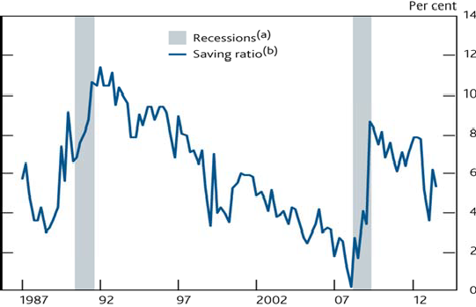

1. Recessions are defined as at least two consecutive quarters of falling output (at constant market prices) estimated using the latest data. The recessions are assumed to have ended once output began to rise.
2. Percentage of household post-tax income.



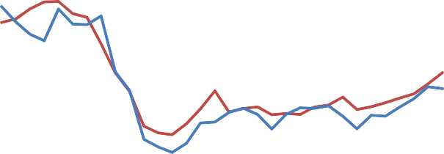

Housing starts(b)

(left‐hand scale)

Housing transactions(a)

(right‐hand scale)

Thousands per month

160

140

120

**Chart 2: Housing market activity**

Thousands per month

20

18

16

2013

2011

2009

2007

2005

‐30

‐40

Range of investment intentions surveys(a)

20

10

0

‐10

‐20

ONS business investment

Percentage changes on a year earlier

30

Sources: Department for Communities and Local Government, HM Revenue and Customs, ONS and Bank calculations.

1. Number of residential property transactions in the United Kingdom with a value of £40,000 or above.
2. Number of permanent dwellings in the United Kingdom started by private enterprises up to 2011 Q1 (seasonally adjusted by Bank staff). Data for 2011 Q2 to 2013 Q4 have been grown in line with seasonally adjusted data for permanent dwelling starts by private enterprises in England.

2006 2007 2008 2009 2010 2011 2012 2013

0

0

20

40

100

80

60

14

12

10

8

6

4

2

Sources: Bank of England, BCC, CBI, CBI/PwC, ONS and Bank calculations.

(a) Includes survey measures of investment intentions from the Bank’s Agents, BCC and CBI, scaled to match the mean and variance of four-quarter business investment growth since 1999. Measures weight together sectoral surveys using shares in real business investment.

**Chart 3: Business investment**



Pre‐crisis trend

Indices: 2008 Q1 = 100

120

2000 2002 2004 2006 2008 2010 2012

(a) Pre-crisis trend is projected using quarterly growth rates between 1999 and 2007.

110

100

90

80

70

60

**Chart 4: Whole economy productivity(a)**



**Chart 5: UK current account**

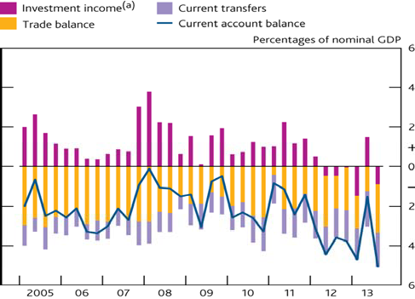

(a) Includes compensation of employees.

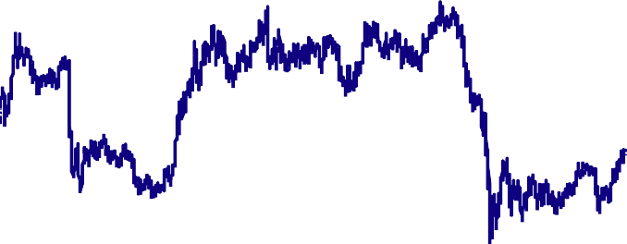

**Chart 6: Sterling ERI**

Index: January 2005=100

115

110

105

100

95

90

85

80

75

70

1990 1992 1994 1996 1998 2000 2002 2004 2006 2008 2010 2012 2014



**Chart 7: Survey indicators of capacity utilisation(a)**

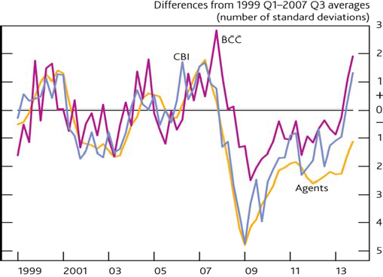

Sources: Bank of England, BCC, CBI, CBI/PwC, ONS and Bank calculations.

(a) Measures are produced by weighting together surveys from the Bank’s Agents (manufacturing and services), the BCC (non-services and services) and the CBI (manufacturing, financial services, business/consumer services and distributive trades) using nominal shares in value added. The surveys are adjusted to have a mean of zero and a variance of one over 1999 Q1 to 2007 Q3. The BCC data are non seasonally adjusted.

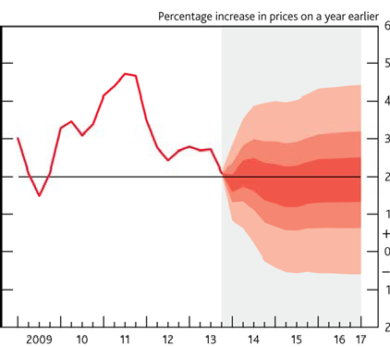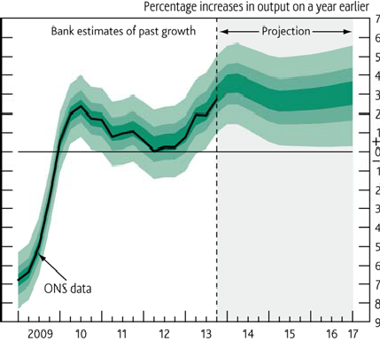



**Chart 8: CPI inflation projection**



**Chart 9: GDP growth projection**